**Usability Report**

Ethan Carmona

***Introduction***

For this usability report, I focused on haunted houses in the Indianapolis area. With Halloween coming soon, I started to receive more Halloween shopping advertisements. Most recently, I received plenty of haunted house advertisements which inspired my selection. After just a quick glance at each website, I immediately spotted similar patterns and possible design issues.

With this report, I aim to identify different aspects of a website which cause frustration or confusion among users. I plan to identify these through my own usability test and user observations. Next, I will show my findings and provide recommendations to improve the website’s overall usability.

***Research***

As mentioned in the introduction, I chose to investigate Haunted House websites in the Indianapolis area. I managed to find six fitting websites which can be seen below.

|  |  |
| --- | --- |
| ***Necropolis Underground Haunted Attraction***   * <https://www.necropolisunderground.com/> * Indianapolis, IN | Photo of axe |
| ***Nightmare on Edgewood***   * <https://nightmareonedgewood.com/> * Indianapolis, IN |  |
| ***The Thirteenth Hour Haunted House***   * <https://www.thirteenthhourindy.com/> * Indianapolis, IN |  |
| ***Hanna Haunted Acres***   * <https://hannahauntedacres.com/> * Indianapolis, IN |  |
| ***Indy Scream Park***   * [Website](https://indyscreampark.com/?gad_source=1&gclid=Cj4KCQjwmt24BhDPARItAJFYKk0m0DO3mh3h_H7XbqOAMeFt3l4872NiZjqpGsZafZ68hUanyknmfh3XGgIz2BAC8P8HAQ) * Anderson, IN |  |
| ***Fright Manor***   * <https://frightmanor.com/> * Southport, IN |  |

As I was searching for these six Haunted House websites in the Indianapolis area, I noticed certain similarities and themes. These themes existed not just within these six websites, but in almost every Haunted House/Haunted attraction website I came across. One theme was the color scheme. Almost every website was designed around a black/green or black/orange color scheme.

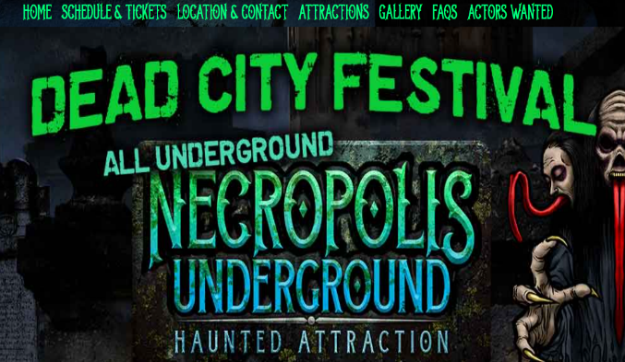

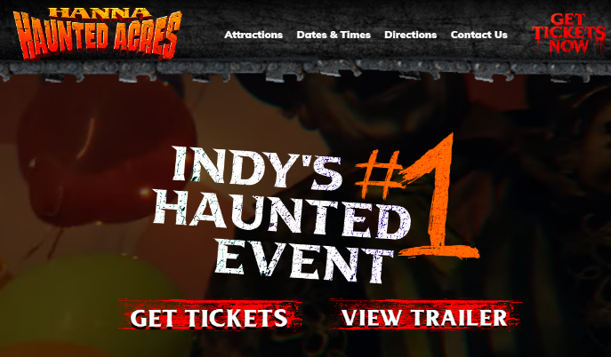

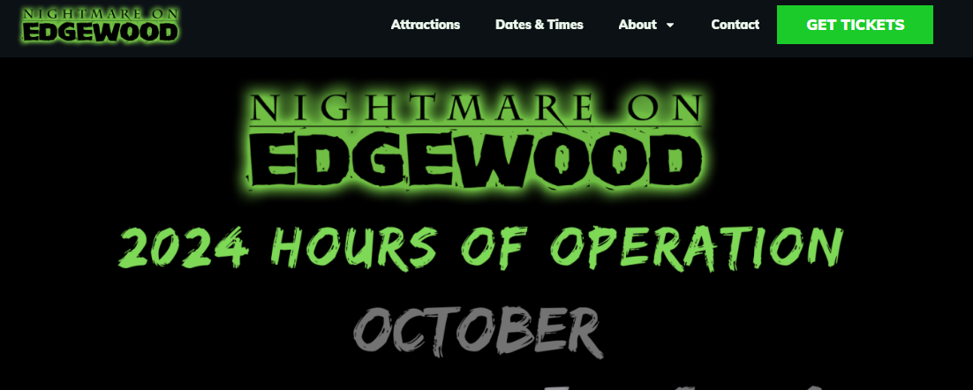

Along with the focus on color, the use of ‘scary’ or ‘spooky’ style fonts can be observed with each website. With each heading or logo, the font contains jagged edges, weathered texture, and distressed coloring to add an extra haunted level to the website.

Another common aspect I observed from these websites is the use of embedded videos and images on the home page. For five of the six websites, the first thing a user sees on the front page is some sort of scary video or image. It sets the tone for their customers by giving them a look at their costumes and decorations. For websites that display a video, the video itself is very intense. It captures the exciting features of the attraction along with its costumes, layout, and plenty of flashing colors.

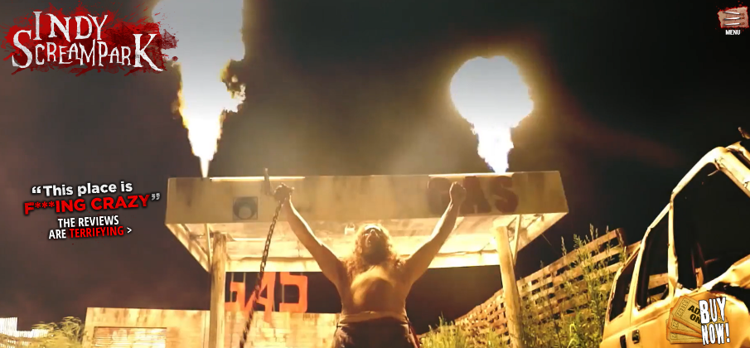

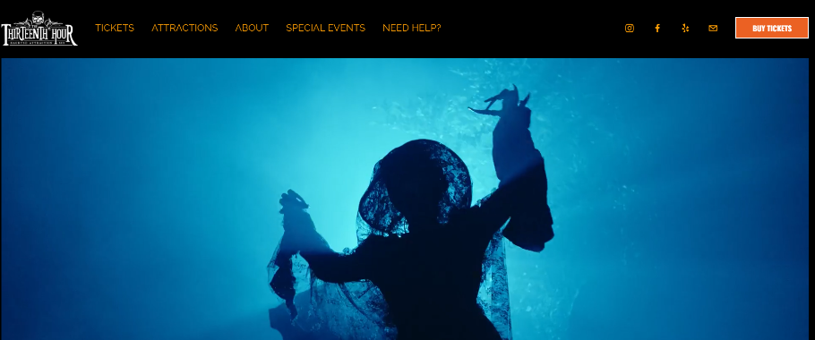

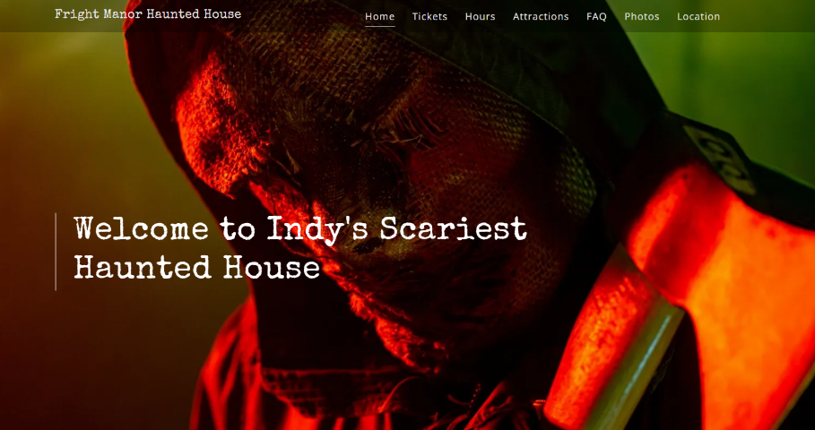

As for the call to action, the goal for each site is for a user to buy a ticket. Across every website a buy tickets button is placed on the home page. The general format for buying tickets on each website is primarily the same. The user is redirected to another page where they select a date, the type of ticket, and the number of tickets needed. Displayed below are different buttons present on the home pages; some are more attention grabbing than others.

|  |  |
| --- | --- |
|  |  |
|  |  |

I have chosen to further evaluate Necropolis Underground’s website. From a design standpoint, it differs the most from the other five websites. There is no embedded video or image promoting the attraction and it does not follow a lot of modern web conventions as the others do.

***Analysis & Evaluation***

At first glance, the Necropolis Underground website is a bit bland, and underwhelming compared to the other haunted house website. The page is cluttered with graphics with no active features to grab the user’s attention.

**Problem 1: Buttons**

The first issue I identified was that certain elements appeared to be buttons or links to other pages, when in fact they were not. As I was first exploring this page there were two sections in particular that contained these issues.

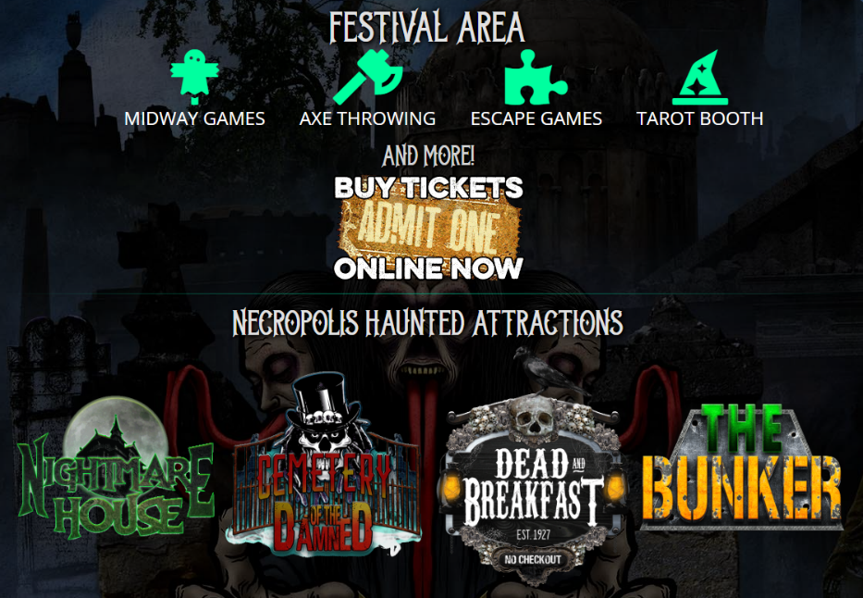

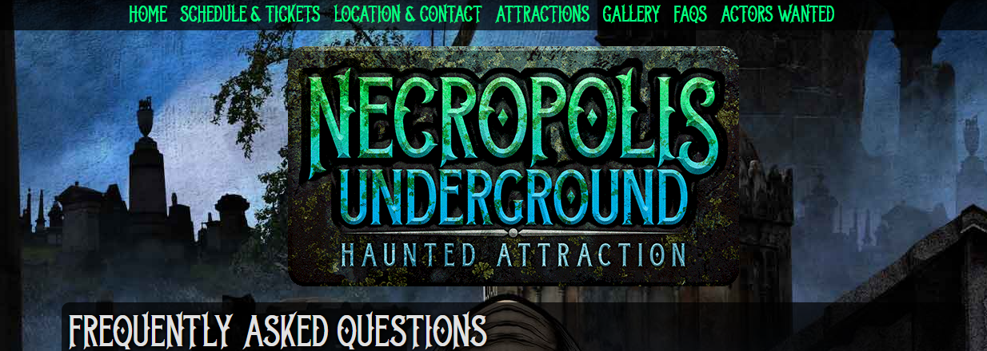

The first screenshot was taken from the homepage, and it is located in the middle of the page. At first glance, I thought the icons in the ‘Festival Area’ were buttons that would lead me to more information about each feature. I clicked through each icon and discovered they were just images. A similar experience happened to me for the images under ‘Necropolis Haunted Attractions’. I thought that each image would take me to a page with descriptions for each attraction. However, they were also just images. The second screenshot is the website logo. It is fixed at the top of every page except for the Home and Actors Wanted page. Conventionally, clicking on this element would take users back to the homepage. However, once again the element is just an image not leading user anywhere.

**Problem 2: FAQ**

The FAQ page of this website is long, too long. There are over 30 questions on this page, making it cluttered and difficult for users to find answers to their questions. Additionally, there is little spacing between each question making it harder to read from question to question. The text under each question is also small and the grey text does not contrast enough from the transparent black background and the website’s background. (The screen shot below only includes about half of the page)

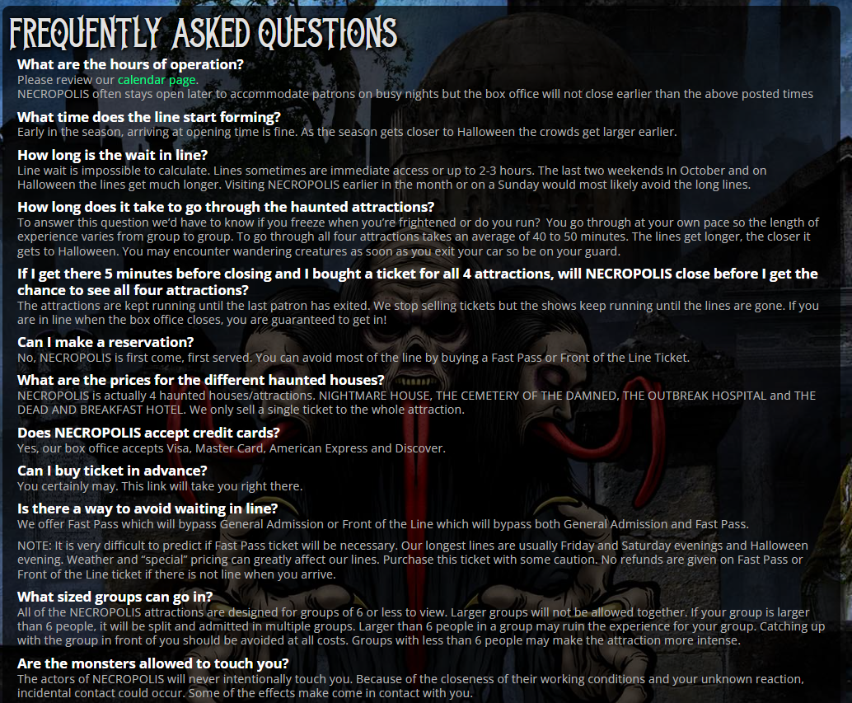

**Problem 3: Schedule**

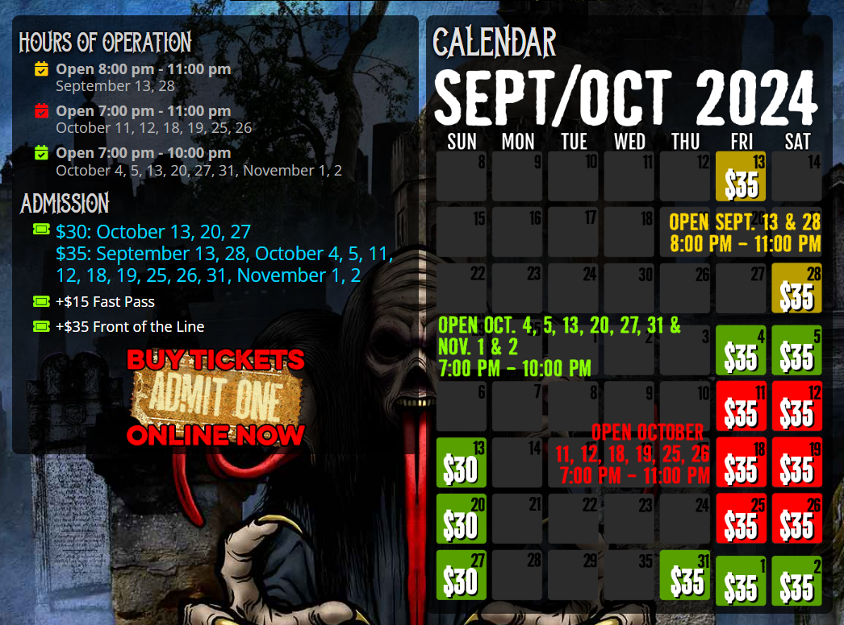

The schedule presented on the website is unique and creative, but I think the design ends up overcomplicating the schedule information. There are two main elements on the page, both of which accomplish the same goal and present the same information. The section on the left appears to be a legend for the schedule on the right, however there is also information presented on the schedule, making the ‘legend’ useless.

**Problem 4: Purchasing Tickets**

Necropolis Underground has four attractions that customers can visit. However, it is not so clear whether you need to buy individual tickets for each attraction or if one ticket grants you access to all of them. I ended up finding this information on the Buy Tickets page, but I glanced over this information because it blends in with the other description text. Additionally, there is no way to manually input a specific number of tickets. The only way is to click the plus icon. This can become a problem for users who need to purchase a large number of tickets.

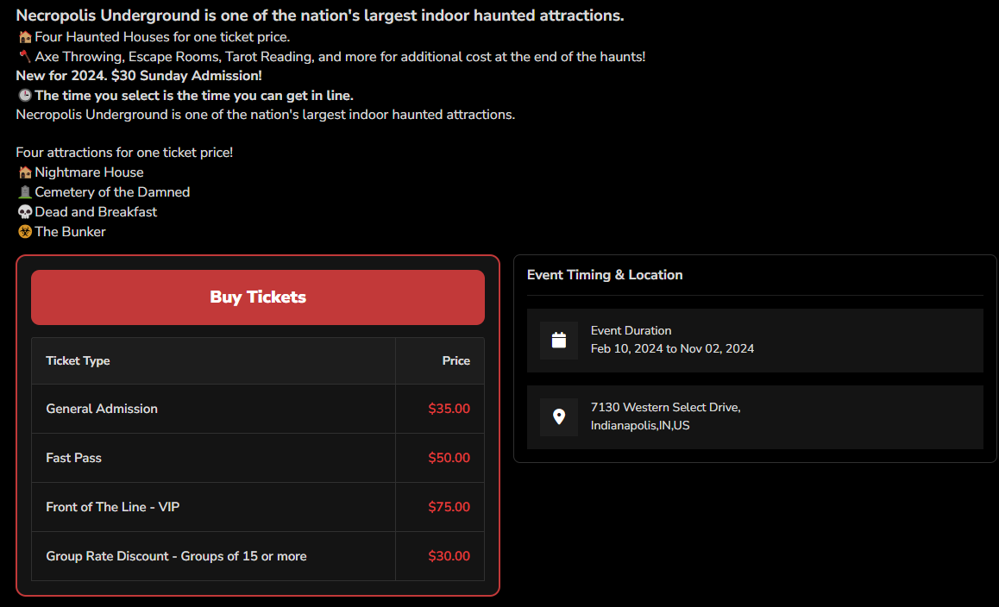

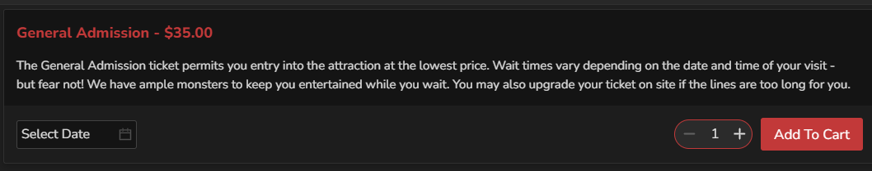

***Background on Users***

I chose three users to conduct my tasks on. These users are all IU undergraduate students in their 3rd year. Two are Luddy majors and one is a Media Advertising major. None of the users have been to Necropolis Underground nor have they used the website before. When asked about their tech savviness on a scale of 1-10 (1 being the lowest) the three users gave themselves scores from 7-9

***Findings***

All users were given the same information and questions regarding the website and testing.

**Problem 1: Buttons**

To begin the user test, I instructed each user to scroll through the homepage. They were not allowed to move their cursor to hover over or click any element. I then asked them, “Go through the page, and say out loud section by section which elements you think are buttons or links to another page.” All three users immediately mentioned the navigation bar and the flashing buy tickets icon. Users 1 and 3 were confident that the ‘Festival Area’ icons were buttons while User 2 was unsure if they were buttons or not. Another section they brought up was the ‘Haunted Attraction’ section. User 3 was confident that the images were buttons or links, User 2 was confused for a second but ultimately decided they were links, and User 1 did not comment on them at all.

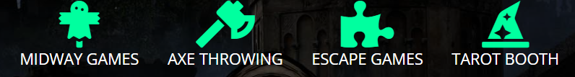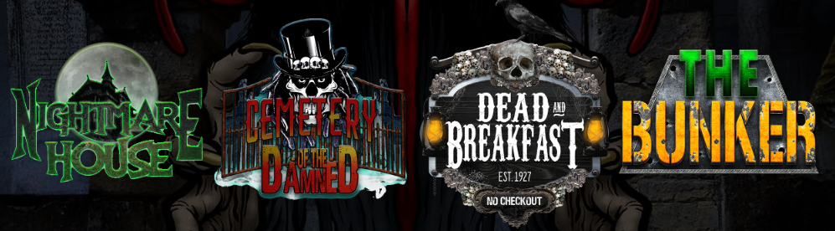

***Recommendations***

* Turn these elements into buttons/links
* For the ‘Festival Area’ icons, turn them into buttons and add responsive hover designs. When the user clicks on them, take them to a page with descriptions for each feature. This same concept can be applied to the ‘Haunted Attraction’ section elements.
* Remove elements entirely from home page as they are easily accessible through the navigation bar

**Problem 2: FAQ**

Before testing users on this usability issues, I gave each user the following scenario:

*You* *are in charge of a company outing at Necropolis Underground. You need to know some information beforehand and eventually book a number of tickets.*

Right after this I gave each user the following task and asked question A after they completed the task.

*Find out if you are able to bring a camera inside the haunted house*

1. *How hard was finding this information from 1-5? (1 being easy and 5 being very difficult)*



Each user began on the home page. All users moved to the navigation bar almost immediately. Users 1 and 2 clicked on multiple navigation items before finding their desired information. However, User 1 did not find the information under the FAQ page, but instead found it in a disclaimer section in the Buy Tickets page. User 3 navigated to the FAQ page immediately. Once on the FAQ page, Users 2 and 3 scanned and scrolled through the page. User 2 ended up using CTRL F and User 3 eventually found the information after re-reading the page. Users 1 and 2 gave the task a score of 2 and User 3 gave a score of 3. User 2 said, “there are too many questions” and User 3 commented that it would have been easier if he didn't have to re-read the page.

***Recommendations:***

* Decrease the number of questions on the FAQ page to decrease clutter.
* Organize questions by similarity and type of question so users do not have to read each question individually.
* Increase the font size and contrast of the answer text to improve readability.

**Problem 3: Schedule**

Sticking with the same scenario as Problem 2, I wanted to see how easy or challenging it was for the users to understand the schedule page. I gave each user the following task and questions:

*Find out if Necropolis is open on October 19. If they are open, what are the hours?*

1. *Was this Easy, Neither difficult nor easy, or Difficult*
2. *What about the page made it [Easy, Neither difficult nor easy, or Difficult]*

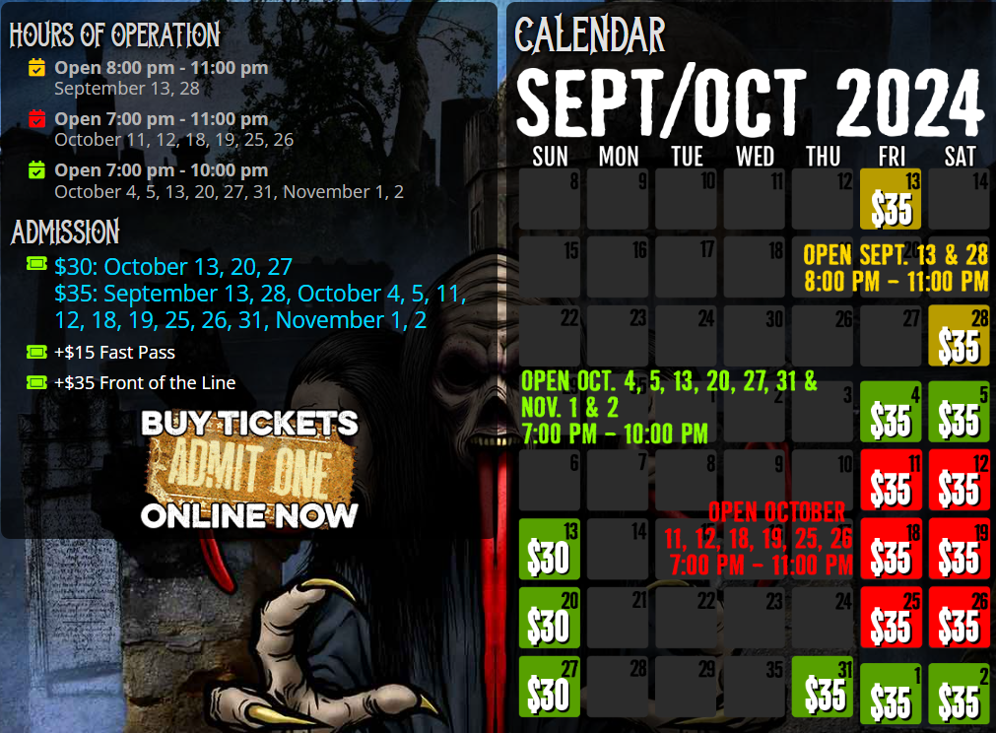

All users managed to locate the Schedule page easily by using the Navigation Bar. Users 1 and 2 used the left element to find the dates and hours while User 3 used the right element to find the information. All three users rated the task as ‘Easy’ saying the ‘Schedule’ item in the Navigation Bar made it easy to find the correct page. When they arrived at the page User 1 and 2 used the left ‘Hours of Operation’ section, and User 3 used the one on the right. When asked about what made the task confusing, all users mentioned the color aspect of the schedule. User 1 and 3 mentioned that the red coloring made it seem that certain dates were unavailable or at a worse price compared to the dates in green. User 2 believed there was no need for color coding at all and User 2 wondered why they needed two ‘Hours of Operations’ sections.

***Recommendations***

* Use a color other than red as people might incorrectly associate the red-colored dates with unavailable or bad.
* Find a way to combine or eliminate one of the two ‘Hours of Operation’ sections as each user only used one section and not both

**Problem 4: Purchasing Tickets**

In order to assess the ticket purchasing process, I gave users the following task and questions:

*You must find an attraction you like best. Once you have found them, you must purchase 30 tickets. Stop after you add the tickets to cart.*

1. *What made this task easy*
2. *What made this task difficult/frustrating*

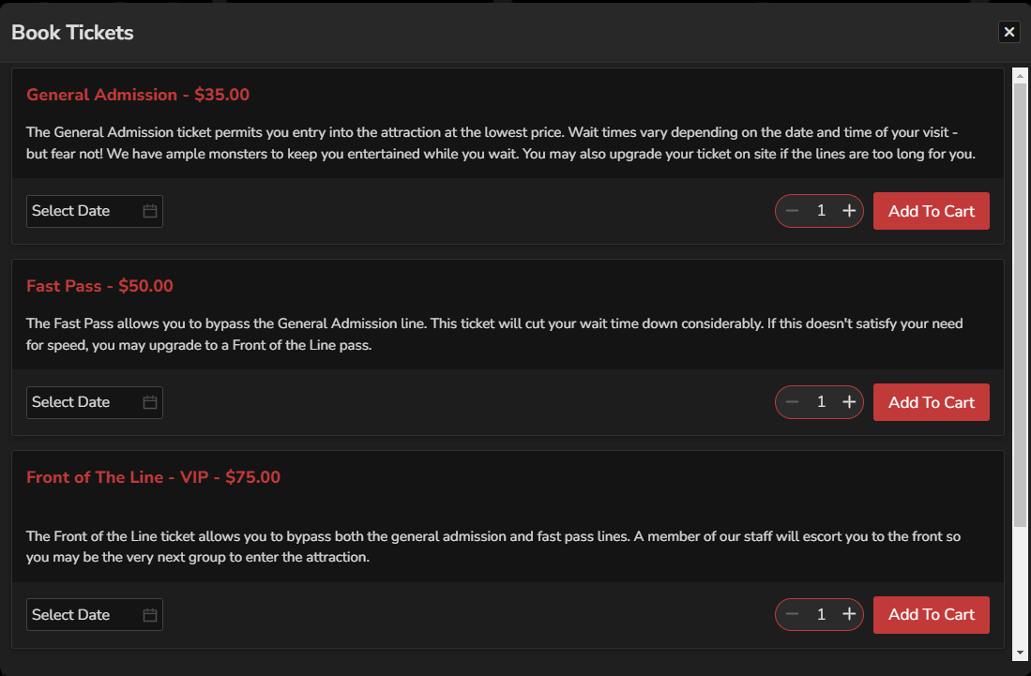

Every user had the same general path to purchasing the tickets. They all visited the ‘Attractions’ page using the Navigation Bar and viewed each option. They then clicked the Buy Tickets button located on the bottom of the page. User 1 read through the types of tickets and explained he was confused on which ticket to get. Users 2 and 3 assumed to select a General Admission ticket. Users 2 and 3 tried to manually type in the desired number of tickets before using the plus icon. After all the tickets were selected, all users tried to purchase tickets before selecting a date to which they received an error message.

All users said that the surplus of Buy Ticket buttons throughout the website made it easy to find the ticket page. As for frustrations, Users 2 and 3 tried visiting the ‘Attractions’ page by clicking on the ‘Haunted Attraction’ images on the home page. User 1 had no issue with using the plus icon, but Users 2 and 3 wishes they could type in the number of tickets.

***Recommendations***

* Include a feature to allow users to type in the desired number of tickets to be purchased. Using the plus icon could be time consuming and inconvenient for large purchases.
* Users clicked on the ‘Haunted Attractions’ images on the home page once again, however this issue has already been addressed in Problem 1.
* Include larger text or information section that informs users that a General Admissions ticket will allow them to access all four attractions. A larger font size could be used, and an information section could be added to the ‘Attractions’

***Conclusion***

The purpose of this report was to identify multiple elements and features of the Necropolis Underground website which caused confusion or frustration to users. In order to do this, I first conducted an individual user test and recorded my findings and opinions. I then performed three user tests and recorded my observations and their opinions. The users ended up having an easier time navigating the website than I thought. The average rating for a task was ‘Easy’ or a rating of 2 on a 1-5 navigation scale. The overall design and organization of the website seemed to be a common feature which each user wanted to see changed or improved. Additionally, restructuring the FAQ page, redesigning certain icons to remove confusion, and redesigning the Schedule page seem to address the overall usability issues. However, to narrow down or confirm these suggestions, additional user testing should be done. These users should have differing demographics and different levels of web experience and tech savviness.

***Addendum***

I feel I was fairly successful at creating tasks for each usability issue I found. With each user task I was able to observe exactly what I needed to do in order to find possible flaws in the website. Additionally, I was able to get each user to share their insights by asking follow-up questions which varied on their performance for each task. Through these tasks I was able to confirm that the usability issues I analyzed were present. However, for some tasks I was surprised to see that some users gave a low difficulty rating. For example, all three users completed the FAQ task faster than I imagined and they were not as frustrated as I was trying to find certain information. If there was a question I could have done differently, I would ask each user to purchase a different number of tickets. This way I could see how each user reacted to buying different numbers of tickets.

***User Test/Questions***

View the home page without clicking or hovering over anything.

How Tech Savvy are you from 1-10 (1 being not technical at all):

1. What do you like and dislike about the design?

**Task 1**

Ask users to look at home page. Scroll though the page without clicking or hovering over any element and say what elements you believe are buttons/links to another page.

**Task 2**

**Scenario**: You are in charge of a company outing at Necropolis Underground. You need to know some information beforehand and eventually book a number of tickets.

Find out if you can bring a camera inside the haunted house

* How hard was finding this information from 1-5?
* 1 being easy and 5 being very difficult

**Task 3**

Find out if Necropolis is open on October 19. If they are open, what are the hours?

1. Was this Easy, neither difficult nor easy, or Difficult
2. What about the page made it (Easy, neither difficult nor easy, or Difficult)
3. Is there anything particularly confusing about this page?

**Task 4**

You must find an attraction you like best. Once you have found them, you must purchase 30 tickets. Stop after you add the tickets to cart.

1. What made this task easy
2. What made this task difficult/frustrating

**Exit Question**

If you could change one thing about this site, what would it be?

Less complex, remove all the button looking items on home page

**User Testing Notes**

***User 1***

View the home page without clicking or hovering over anything.

Tech savvy: 1-10? 7

1. What do you like and dislike about the design?

Like: Likes the buy tickets icon, draws attention

Dislike: Too many colors, overwhelming

* Combinations of colors and pictures

1. Ask users to look at home page. Scroll though the page without clicking or hovering over any element and say what elements you believe are buttons/links to another page

* Festival area
* Buy tickets
* Nav bar
* Footer, design by sinister vision
* Individual pictures and videos

Necropolis Underground Haunted:

Scenario: You are in charge of a company outing at Necropolis Underground. You need to know some information before hand and eventually book a number of tickets.

Find out if you are able to bring a camera inside the haunted house

* How hard was finding this information from 1-5?
* 1 being easy and 5 being very difficult

Goes to location and contact first

Then attractions

Reads through attraction descriptions

Goes to buy tickets

Clicks on warning -> warnings slash disclaimer

Scale: 2, searching for it for a while  
1:04.89

Find out if Necropolis is open on October 19. If they are open, what are the hours?

* Was this Easy, neither difficult nor easy, or Difficult
* What about the page made it (Easy, neither difficult nor easy, or Difficult)

19.96

Clicked on the Schedule and tickets

Easy

* What about the page made it easy to find
* Title of schedule and tickets
  + Left side of page, hours of operation made it easier
* Anything confusing about page?
  + Associated red with bad price or not available, and green with better prices

You must find an attraction you like best. Once you have found them, you must purchase 30 tickets. Stop after you add the tickets to cart.

* What made this task easy
  + Lots of buy tickets buttons everywhere
* What made this task difficult/frustrating
  + When buying the tickets, the details on each ticket does not tell you what the tickets can get you into
  + Wishes there was tickets on the attractions page

Attractions first

Scrolls through options, picks dead and breakfast

* Cant buy it on attraction page

Schedule and tickets -> buy tickets

Confused on which ticket option to select

Time 1:18

Exit Question

If you could change one thing about this site, what would it be?

Less complex, remove all the button looking items on home page

***User 2***

View the home page without clicking or hovering over anything.

Tech savvy: 1-10: 8

1. What do you like and dislike about the design?

Like: Page gets darker at the bottom,

Dislike: Does not like the buy tickets icon, flashing red, don’t like the flashinglights

1. Ask users to look at home page. Scroll though the page without clicking or hovering over any element and say what elements you believe are buttons/links to another page

* All of nav bar
* Social media buttons
* Festival area, would go hover over to check
* Buy tickets
* Haunted attractions, thinks it would lead you to attraction details page

Necropolis Underground Haunted:

Scenario: You are in charge of a company outing at Necropolis Underground. You need to know some information before hand and eventually book a number of tickets.

Find out if you are able to bring a camera inside the haunted house

* Schedule and tickets
* Location and contact
* FAQ’s
  + Scrolling down page
  + Finds it through ctrl f
* How hard was finding this information from 1-5?
* 1 being easy and 5 being very difficult
  + With control F
    - 1
  + 2 without control F
  + “There are too many questions”

Time: 38.76

Find out if Necropolis is open on October 19. If they are open, what are the hours?

* Was this Easy, neither difficult nor easy, or Difficult
  + Easy
* What about the page made it (Easy, neither difficult nor easy, or Difficult)
  + From home page: Nav bar said schedule
  + From Schedule page
    - The first thing it showed was hours of operation
    - Read from left to right so started from left
  + What is confusing about this page?
    - Make them all one color.
    - Does not make sense for them to be different colors because the only thing different is the times

Schedule and tickets

* Looks at left side

Time: 31.24

You must find an attraction you like best. Once you have found them, you must purchase 30 tickets. Stop after you add the tickets to cart.

* What made this task easy
  + Attractions is at the top so it was obvious to go there
  + Buy tickets was on the page
* What made this task difficult/frustrating
  + The attraction details do not really tell much about the attraction itself. It gives a background and fictional story.
* Going to attractions
  + To look at attraction details
* Hits buy tickets and the bottom
* Clicks general admission
  + Tries to input 30 manually
  + Clicked the button 30 times
  + Clicked buy before selecting date

Time: 1:10:23

Exit Question

If you could change one thing about this site, what would it be?

* Would change the attraction details
* Color scheme possibly

***User 3***

View the home page without clicking or hovering over anything.

Tech savvy: 1-10: 9

1. What do you like and dislike about the design?

Like: Creative, Buy tickets button grabs user attention

Dislike: Distracting background, a lot going on distracts from main content

1. Ask users to look at home page. Scroll though the page without clicking or hovering over any element and say what elements you believe are buttons/links to another page

* Navbar
* Festival area
* Buy tickets
* Attractions
* Gallery at the end
* “Literally everything”
* Social media icons

Necropolis Underground Haunted:

Scenario: You are in charge of a company outing at Necropolis Underground. You need to know some information before hand and eventually book a number of tickets.

Find out if you are able to bring a camera inside the haunted house

Looking at navbar

FAQ

* Looking through
* Scrolling
* Goes back up to top and rescans

Time: 49.78

* How hard was finding this information from 1-5?
* 1 being easy and 5 being very difficult
  + 3
  + Had to scroll and reread and no control f

Find out if Necropolis is open on October 19. If they are open, what are the hours?

* Was this Easy, neither difficult nor easy, or Difficult
  + Easy
* What about the page made it (Easy, neither difficult nor easy, or Difficult)
  + From home page: Says on navbar
  + From schedule page: Description on calendar made easy to find
* Confusing on this page: Has hours on operation on two areas of page
* Tried to click on the actual date for description

Colors: Associates red with bad, closed, unavailable

Looks at nav bar

Schedule and tickets

* Looks at right side

Time: 35.02

You must find an attraction you like best. Once you have found them, you must purchase 30 tickets. Stop after you add the tickets to cart.

* What made this task easy
  + The buy tickets button made it easy to find the buy tickets page
* What made this task difficult/frustrating
  + Finding the attractions
    - Tried to click on the buttons on the homepage instead of navbar
    - Wishes there was a manual input for ticket numbers

Tries to click on attractions on home page

Buy tickets button

Stuck on buy ticket page for a second

* Clicks on other links accidentally

Find attractions on navbar

* Choose date
* Clicks 55

Exit Question

If you could change one thing about this site, what would it be?

* Make the navbar bigger
* Less background, basic layout
* Separate content on home page